Penetration testing
Phase 1
Information gathering

Information gathering = reconnaissance
It help in the other phases of the penetration testing.
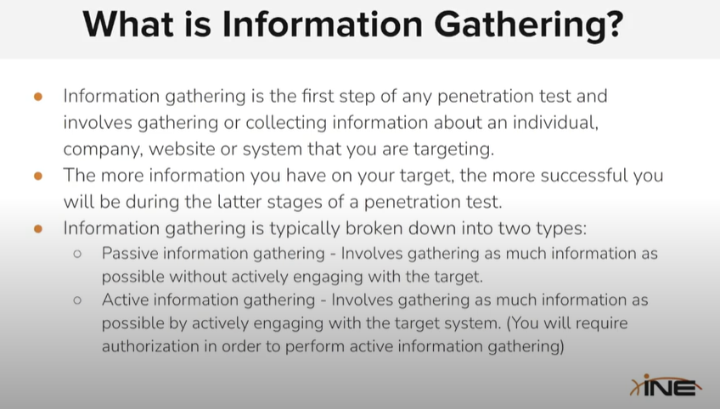

There are a lot more of them but some of them are :
